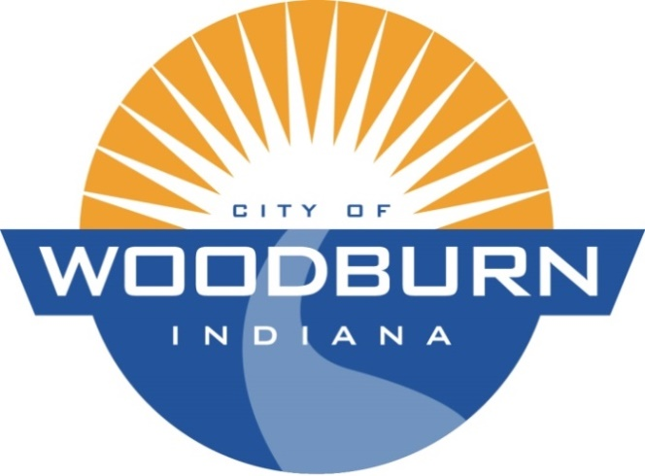

Board of Works and Public Safety:
Commencing at 5:30pm under the direction of Mayor Joseph Kelsey
Board Members: Kevin Heckley, Mark Hoeppner

Police Chief: Brad Parker

Superintendent: Ryan Walls

Clerk-Treasurer/Secretary: Timothy Cummins

Old Business:
N/A

New Business:
N/A

* May Occur at a Future Meeting

THE AGENDA FOR THE BOARD OF WORKS AND PUBLIC SAFETY
AND
THE AGENDA FOR THE COMMON COUNCIL
FOR
MONDAY, FEBRUARY 15th, 2021

Common Council:
Commencing at 7:00pm under the direction of Mayor Joseph Kelsey
Council Members: Michael Martin, Tonya Thompson, Dean Gerig, Daniel Watts, Michael Voirol

Police Chief: Brad Parker

Superintendent: Ryan Walls

Clerk-Treasurer/Secretary: Timothy Cummins

Old Business:
N/A

New Business:
- *Discussion RE: Sturtz Public Management and JPR Contracts
- Determine Appointment Method of Representatives to the Proposed Fire Territory Board
- Review Outstanding Checks from 2019 and Earlier
- Review 2020 End of Year Figures

