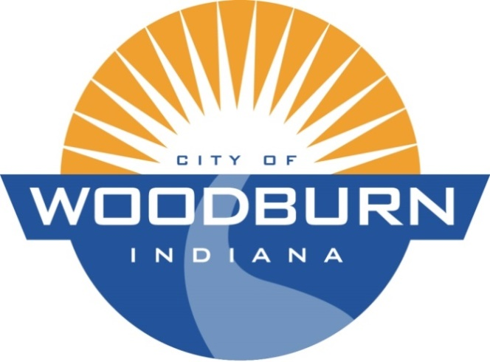

Board of Works and Public Safety:
Commencing at 5:30pm under the direction of Mayor Joseph Kelsey
Board Members: Kevin Heckley, Mark Hoeppner

Police Chief: Brad Parker

Superintendent: Ryan Walls

Clerk-Treasurer/Secretary: Timothy Cummins

Old Business:
N/A

New Business:
- SRF Draws # 45 and # 46

THE AGENDA FOR THE BOARD OF WORKS AND PUBLIC SAFETY
AND
THE AGENDA FOR THE COMMON COUNCIL
FOR
MONDAY, JULY 15TH, 2019

Common Council:
Commencing at 7:00pm under the direction of Mayor Joseph Kelsey
Council Members: Michael Martin, John Renner, Dean Gerig, Daniel Watts, Michael Voirol

Police Chief: Brad Parker

Superintendent: Ryan Walls

Clerk-Treasurer/Secretary: Timothy Cummins

Old Business:
N/A

New Business:
- Midwest Weld Public Hearing RE: Abatement Compliance
- Res. 19-239 (Waiving Non-Compliance for Midwest Weld RE: SOB)
- Election Board Letter RE: Waiving 2020 Election

