RESOLUTION 19-236
A RESOLUTION OF THE CITY OF WOODBURN, INDIANA
COMMON COUNCIL REGARDING
TRANSFERS OF APPROPRIATIONS WITHIN MULTIPLE FUNDS AS WELL AS A TRANSFER BETWEEN FUNDS

WHEREAS, within multiple funds there are line items that require additional monies allocated for the 2019 calendar year and a transfer of appropriation is required as allowed by IC 6-1.1-18-6;
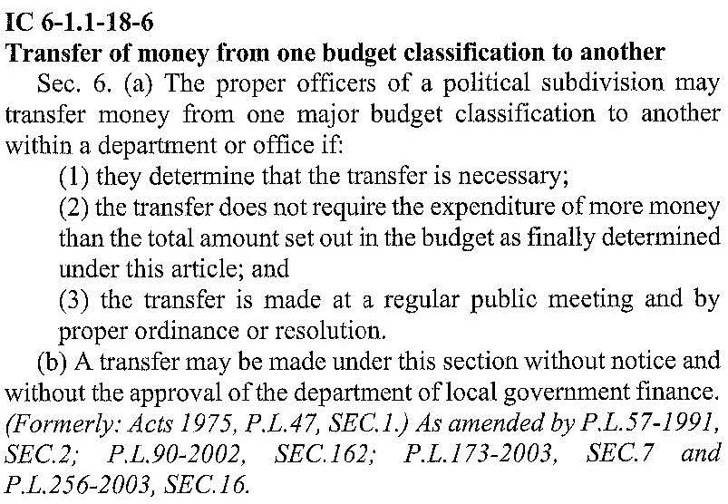
WHEREAS, money was paid out to an officer from Fund 248, Police Department Grants, with the understanding of reimbursement through the State’s Operation Pull Over program, with which it was never properly submitted and consequently a transfer of funds is necessary to zero out the balance of said fund and the general fund will serve this purpose;
WHEREAS, the Local Road and Bridge Matching Fund, known locally as Fund 258, requires a transfer of money from other funds in order to allow for spending as approved by the 2019 Budget for the City of Woodburn;
NOW THEREFORE, BE IT RESOLVED by the Common Council of the City of Woodburn:

That within the GENERAL FUND, the following lines are debited as described:
101-002-000118 PART TIME POLICE CLERK, in the amount of $14,500.00
101-002-000221 FUEL POLICE DEPARTMENT, in the amount of $4,000.00
Total Debit: $18,500.00
And, within the GENERAL FUND, the following lines are credited as described:
101-001-000442 IT SERVICES, in the amount of $2,000.00
101-002-000117 PART TIME OFFICER, in the amount of $12,500.00
101-002-000240 OTHER SUPPLIES, in the amount of $4,000.00
Total Credit: $18,500.00
This appropriation transfer will result in a net transfer of $0.00 within the GENERAL FUND.

That within the LOCAL ROAD AND STREET, the following line is debited as described:
202-000-000384 STREET AND SIDEWALK, in the amount of $4,000.00
Total Debit: $4,000.00
And, within the LOCAL ROAD AND STREET, the following line is credited as described:
202-000-000201 TREE/POLE REMOVAL, in the amount of $4,000.00
Total Credit: $4,000.00
This approp. transfer will result in a net transfer of $0.00 within LOCAL RD AND STREET.

That within the EDIT FUND, the following lines are debited as described:
444-000-000131 CCG-ENGINEERING, in the amount of $5,000.00
444-001-000301 PROFESSIONAL SERVICES, in the amount of $10,000.00
Total Debit: $15,000.00
And, within the EDIT FUND, the following lines are credited as described:
444-000-000382 PD/UTILITY VEHICLE, in the amount of $5,000.00
444-001-039901 MISC, in the amount of $10,000.00
Total Credit: $15,000.00
This appropriation transfer will result in a net transfer of $0.00 within the EDIT FUND.

That $284.72 be transferred from Fund 101, GENERAL FUND, into Fund 248, POLICE DEPARTMENT GRANTS.
That $5,000.00 be transferred from Fund 201, MOTOR VEHICLE HIGHWAY, into Fund 258, LOCAL ROAD AND BRIDGE MATCHING FUND.
That $16,265.14 be transferred from Fund 203, MOTOR VEHICLE HIGHWAY – RESTRICTED, into Fund 258, LOCAL ROAD AND BRIDGE MATCHING FUND.

Adopted and Resolved this 17th day of June, 2019.

<SIGNATURES ON NEXT PAGE>

COMMON COUNCIL OF THE CITY OF WOODBURN, INDIANA

By: ___________________________________ YEA_____ NAY_____ ABS_____
Daniel Watts, Councilman

By: ___________________________________ YEA_____ NAY_____ ABS_____
Mike Voirol, Councilman

By: ___________________________________ YEA_____ NAY_____ ABS_____
Dean Gerig, Councilman

By: ___________________________________ YEA_____ NAY_____ ABS_____
John Renner, Councilman

By: ___________________________________ YEA_____ NAY_____ ABS_____
Michael Martin, Councilman

ATTEST:

By: ______________________________________
Timothy Cummins, Clerk-Treasurer

The foregoing resolution passed by the Council is signed and approved ( ) / not approved ( ) by me on the same date.

By: ______________________________________
Joseph Kelsey, Mayor of the City of Woodburn

