RESOLUTION 18-234
A RESOLUTION OF THE CITY OF WOODBURN, INDIANA
COMMON COUNCIL REGARDING
TRANSFERS OF 2018 APPROPRIATION WITHIN THE EDIT FUND

WHEREAS, within the EDIT fund there are line items that require additional monies allocated for the 2018 calendar year and a transfer is required as allowed by IC 6-1.1-18-6;
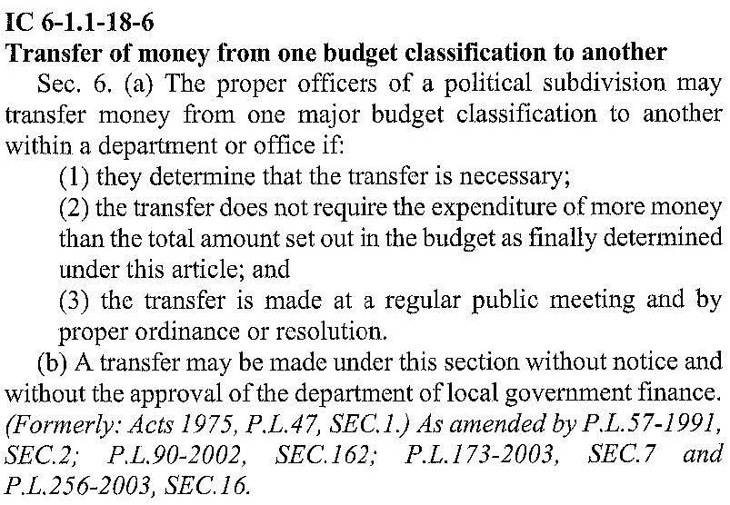
NOW THEREFORE, BE IT RESOLVED by the Common Council of the City of Woodburn:

That within the EDIT FUND, the following line is debited as follows:
444-000-020000 HICKORY STREET CONST., in the amount of $10,000.00
Total Debit: $10,000.00

And, within the EDIT FUND, the following lines are credited as follows:
444-000-000244 UTILITY 2 WAGE, in the amount of $4,000.00
444-001-000301 PROFESSIONAL SERVICES, in the amount of $6,000.00
Total Credit: $10,000.00

This transfer will result in a net transfer of $0.00 within the EDIT FUND.
Adopted and Resolved this 3rd day of December, 2018.
<SIGNATURES ON NEXT PAGE>
COMMON COUNCIL OF THE CITY OF WOODBURN, INDIANA

By: ___________________________________ YEA_____ NAY_____ ABS_____
Daniel Watts, Councilman

By: ___________________________________ YEA_____ NAY_____ ABS_____
Mike Voirol, Councilman

By: ___________________________________ YEA_____ NAY_____ ABS_____
Dean Gerig, Councilman

By: ___________________________________ YEA_____ NAY_____ ABS_____
John Renner, Councilman

By: ___________________________________ YEA_____ NAY_____ ABS_____
Michael Martin, Councilman

ATTEST:

By: ______________________________________
Timothy Cummins, Clerk-Treasurer

The foregoing resolution passed by the Council is signed and approved ( ) / not approved ( ) by me on the same date.

By: ______________________________________
Joseph Kelsey, Mayor of the City of Woodburn

