RESOLUTION 18-231
A RESOLUTION OF THE CITY OF WOODBURN, INDIANA
COMMON COUNCIL REGARDING
TRANSFERS OF MONEY WITHIN A FUND AS WELL AS MULTIPLE ADDITIONAL APPRORIATIONS

WHEREAS, within the Cumulative Capital Development Fund there is a line item that requires additional monies allocated for the 2018 calendar year and a transfer is required as allowed by IC 6-1.1-18-6;
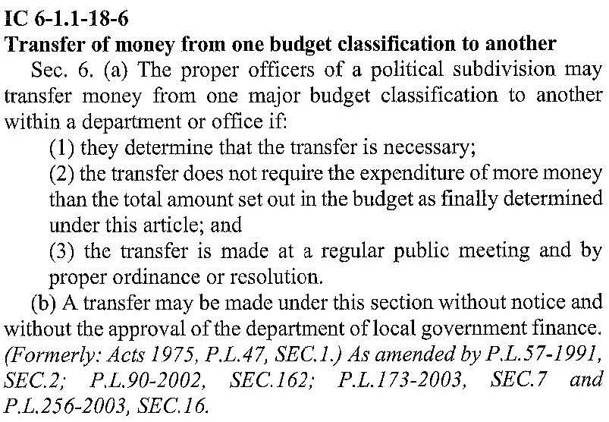
WHEREAS, the 2018 budget accounted for spending towards the 2017 Community Crossings Grant, but not from the appropriate fund; and
WHEREAS, within the Local Road and Bridge Matching Fund, known locally as Fund 258 and by the Department of Local Government Finance (“DLGF”) as Homerule Fund 9503, there is a need to spend additional monies for the 2018 calendar year and an additional appropriation is required; and
WHEREAS, within the Motor Vehicle Highway, known locally as Fund 201 and by the DLGF as Fund 0708, there is a need to spend additional monies for the 2018 calendar year and an additional appropriation is required; and

WHEREAS, the DLGF will be able to authorize this additional spending for 2018 after the City of Woodburn describes the context for that spending; and
WHEREAS, a public hearing took place on September 4th to discuss the additional appropriations within both the Local Road and Bridge Matching Fund and the Motor Vehicle Highway;
NOW THEREFORE, BE IT RESOLVED by the Common Council of the City of Woodburn:

That within the Motor Vehicle Highway, additional spending is required as described:
201-000-000384 Street and Sidewalk, in the amount of $85,000.00
Total Additional Spending: $85,000.00

And, within the Local Road and Bridge Matching Fund, additional spending is required as described:
258-000-000129 Community Crossings Grant, in the amount of $42,635.00
Total Additional Spending: $42,635.00

That within the Cumulative Capital Development Fund, the following lines are debited as follows:
402-000-000391 Training and Equipment, in the amount of $2,000.00
402-000-000393 Promotions, in the amount of $1,000.00
Total Debit: $3,000.00

And, within the Cumulative Capital Development Fund, the following line is credited as follows:

402-000-000150 Networking Projects, in the amount of $3,000.00
Total Credit: $3,000.00

This transfer will result in a net transfer of $0.00 within the Cumulative Capital Development Fund.

Adopted and Resolved this 4th day of September, 2018.

<SIGNATURES ON NEXT PAGE>

COMMON COUNCIL OF THE CITY OF WOODBURN, INDIANA

By: ___________________________________ YEA_____ NAY_____ ABS_____
Daniel Watts, Councilman

By: ___________________________________ YEA_____ NAY_____ ABS_____
Mike Voirol, Councilman

By: ___________________________________ YEA_____ NAY_____ ABS_____
Dean Gerig, Councilman

By: ___________________________________ YEA_____ NAY_____ ABS_____
John Renner, Councilman

By: ___________________________________ YEA_____ NAY_____ ABS_____
Michael Martin, Councilman

ATTEST:

By: ______________________________________
Timothy Cummins, Clerk-Treasurer

The foregoing resolution passed by the Council is signed and approved ( ) / not approved ( ) by me on the same date.

By: ______________________________________
Joseph Kelsey, Mayor of the City of Woodburn

