RESOLUTION 18-226
A RESOLUTION OF THE CITY OF WOODBURN, INDIANA
COMMON COUNCIL REGARDING
TRANSFERS OF MONEY WITHIN MULTIPLE FUNDS AS WELL AS AN ADDITIONAL APPRORIATION

WHEREAS, within multiple funds there are line items that require additional monies allocated for the 2018 calendar year and a transfer is required as allowed by IC 6-1.1-18-6;
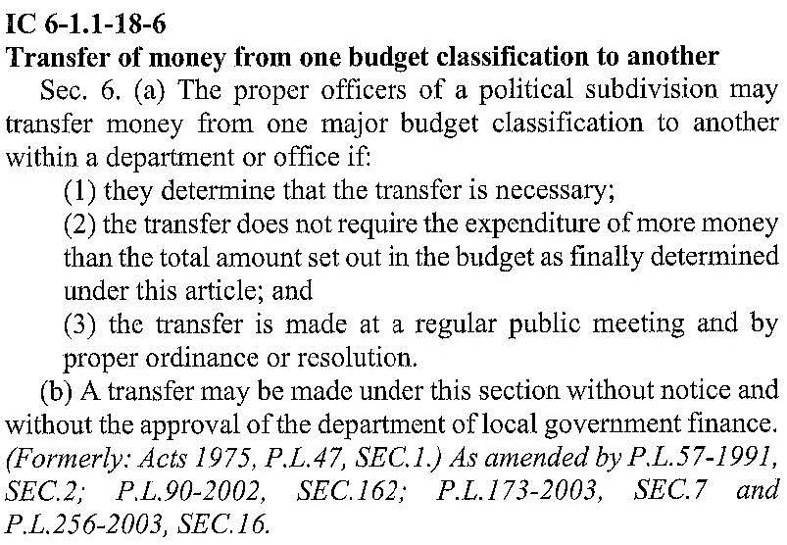
WHEREAS, the 2018 budget accounted for spending towards the 2017 Community Crossings Grant, but not from the appropriate fund; and
WHEREAS, the monies from multiple funds need to be transferred instead into this appropriate fund; and
WHEREAS, within the Local Road and Bridge Matching Fund, known locally as Fund 258 and by the Department of Local Government Finance (“DLGF”) as Homerule Fund 9503, there is a need to spend additional monies for the 2018 calendar year and an additional appropriation is required; and
WHEREAS, the DLGF will be able to authorize this additional spending for 2018 after the City of Woodburn describes the context for that spending; and

WHEREAS, a public hearing took place on May 21st to discuss additional appropriations within the Local Road and Bridge Matching Fund;
NOW THEREFORE, BE IT RESOLVED by the Common Council of the City of Woodburn:

That within the MOTOR VEHICLE HIGHWAY, the following lines are debited as follows:
201-000-000129 COMMUNITY CROSSINGS, in the amount of $120,000.00
Total Debit: $120,000.00

And, within the MOTOR VEHICLE HIGHWAY, the following lines are credited as follows:
000-000-000000 HICKORY STREET CONSTR., in the amount of $38,000.00
201-001-000357 STREET LIGHTS ELECTRICITY, in the amount of $2,000.00
Total Credit: $40,000.00

This transfer will result in a net transfer of $80,000.00 to still be accounted for within the MOTOR VEHICLE HIGHWAY. While not officially considered as a reduction request, internally this $80,000.00 will no longer be considered spendable in 2018.

That within the LOCAL ROAD AND STREETS, the following line is debited as follows:
202-000-000129 COMMUNITY CROSSINGS, in the amount of $15,000.00
Total Debit: $15,000.00
This transfer will result in a net transfer of $15,000.00 to still be accounted for within the LOCAL ROAD AND STREETS. While not officially considered as a reduction request, internally this $15,000.00 will no longer be considered spendable in 2018.

That within the LOIT SPECIAL DISTRIBUTION, the following line is debited as follows:
257-000-000129 COMMUNITY CROSSINGS, in the amount of $27,264.00
Total Debit: $27,264.00
This transfer will result in a net transfer of $27,264.00 to still be accounted for within the LOIT SPECIAL DISTRIBUTION. While not officially considered as a reduction request, internally this $27,264.00 will no longer be considered spendable in 2018.

That within the EDIT FUND, the following line is debited as follows:
444-000-000205 STREETSCAPE IMPROVE., in the amount of $125,000.00
Total Debit: $125,000.00

And, within the EDIT FUND, the following lines are credited as follows:
444-000-000131 CCG-ENGINEERING, in the amount of $12,500.00
444-000-000120 FICA 7.65%, in the amount of $5,000.00
444-000-000121 77 FUND, in the amount of $1,000.00
000-000-000000 HICKORY STREET CONSTR., in the amount of $40,000.00
444-001-000301 PROFESSIONAL SERVICES, in the amount of $66,500.00
Total Credit: $125,000.00

This transfer will result in a net transfer of $0.00 within the EDIT FUND.

Additionally, the following amounts will be transferred between funds as described:
- $80,000.00 from Motor Vehicle Highway into the Local Road and Bridge Matching Fund
- $15,000.00 from Local Road and Streets into the Local Road and Bridge Matching Fund
- $27,264.00 from the Loit Spec. Dist. Into the Local Road and Bridge Matching Fund
This will result in a total transfer of funds to the Local Road and Bridge Matching Fund of $122,264. Considering PO #0018817080 in the amount of $37,539.29 and PO # 0018817111 in the amount of $162,450.00, both issued by INDOT to be paid through the State Auditor’s Office, the total amount considered for appropriation from the Local Road and Bridge Matching Fund in 2018 will be $322,253.29, which was the advertised amount included within the public hearing notice that was in the Journal Gazette on May 7th, 2018.

Adopted and Resolved this 21st day of May, 2018.

<SIGNATURES ON NEXT PAGE>

COMMON COUNCIL OF THE CITY OF WOODBURN, INDIANA

By: ___________________________________ YEA_____ NAY_____ ABS_____
Daniel Watts, Councilman

By: ___________________________________ YEA_____ NAY_____ ABS_____
Mike Voirol, Councilman

By: ___________________________________ YEA_____ NAY_____ ABS_____
Dean Gerig, Councilman

By: ___________________________________ YEA_____ NAY_____ ABS_____
John Renner, Councilman

By: ___________________________________ YEA_____ NAY_____ ABS_____
Michael Martin, Councilman

ATTEST:

By: ______________________________________
Timothy Cummins, Clerk-Treasurer

The foregoing resolution passed by the Council is signed and approved ( ) / not approved ( ) by me on the same date.

By: ______________________________________
Joseph Kelsey, Mayor of the City of Woodburn

