RESOLUTION 17-218

A RESOLUTION OF THE CITY OF WOODBURN, INDIANA
COMMON COUNCIL REGARDING
TRANSFERS OF MONEY WITHIN MULTIPLE FUNDS

WHEREAS, within multiple funds there are line items that requires additional monies for the 2017 calendar year and a transfer is required as allowed by IC 6-1.1-18-6
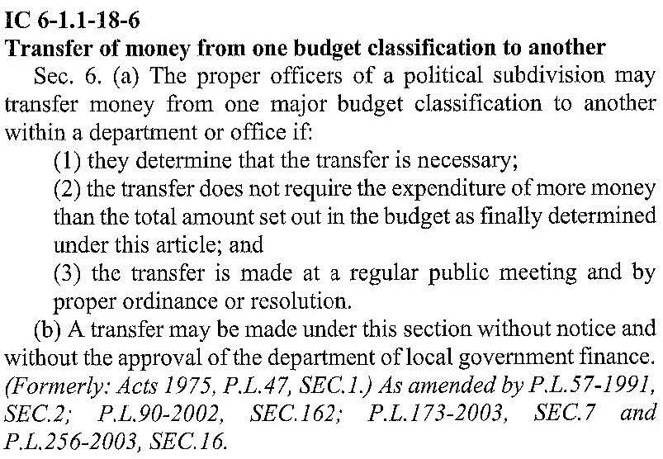
NOW THEREFORE, BE IT ORDAINED by the Common Council of the City of Woodburn,

that within the GENERAL FUND, the following lines are debited as follows:
101-001-000123 GROUP INSURANCE, in the amount of $48,000.00
101-002-000126 PD HEALTH INSURANCE, in the amount of $11,350.00
Total Debit: $59,350.00

And, within the GENERAL FUND, the following lines are credited as follows:
101-001-000111 MAYOR SALARY, in the amount of $3,000.00
101-001-000112 CLERK-TREASURER, in the amount of $3,000.00
101-001-000114 DEPUTY CLERK SALARY, in the amount of $3,000.00
101-001-000211 OFFICE SUPPLIES, in the amount of $5,700.00
101-001-000340 INSURANCE LIABILITY, in the amount of $3,500.00
101-001-000430 COMPUTER HARDWARE, in the amount of $11,000.00
101-001-000442 IT SERVICES, in the amount of $3,500.00
101-002-000116 POLICE CHIEF SALARY, in the amount of $7,500.00
101-002-000119 FULL TIME OFFICER, in the amount of $3,000.00
101-002-000120 FICA 7.65%, in the amount of $750.00
101-002-000213 OFFICE SUPPLIES, in the amount of $4,100.00
101-002-000240 OTHER SUPPLIES, in the amount of $1,000.00
101-002-000354 TELEPHONE POLICE, in the amount of $1,100.00
101-002-000397 OTHER EQUIPMENT, in the amount of $4,200.00
101-002-000440 COMMUNICATION, in the amount of $5,000.00
Total Credit: $59,350.00

This transfer will result in a net transfer of $0.00 within the GENERAL FUND

That within the MOTOR VEHICLE HIGHWAY, the following line is debited as follows:
201-000-000384 STREET AND SIDEWALK, in the amount of $6,500.00
Total Debit: $6,500.00
And, within the MOTOR VEHICLE HIGHWAY, the following lines are credited as follows:
201-000-000120 FICA 7.65%, in the amount of $1,500.00
201-000-000242 SUPERINTENDENT WAGE, in the amount of $1,000.00
201-000-000243 UTILITY 1 WAGE, in the amount of $1,500.00
201-000-000244 UTILITY 2 WAGE, in the amount of $1,500.00
201-001-000357 STREET LIGHTS ELEC, in the amount of $1,000.00
Total Credit: $6,500.00

This transfer will result in a net transfer of $0.00 within the MOTOR VEHICLE HIGHWAY

That within the LOCAL ROAD AND STREET, the following line is debited as follows:
202-000-000384 STREET AND SIDEWALK, in the amount of $2,500.00
Total Debit: $2,500.00

And, within the LOCAL ROAD AND STREET, the following line is credited as follows:
202-000-039901 MISC, in the amount of $2,500.00
Total Credit: $2,500.00

This transfer will result in a net transfer of $0.00 within the LOCAL ROAD AND STREET

That within the COIT PUBLIC SAFETY FUND, the following line is debited as follows:
247-000-000119 FULL TIME OFFICER, in the amount of $750.00
Total Debit: $750.00
And, within the COIT PUBLIC SAFETY FUND, the following line is credited as follows:
247-000-000120 FICA 7.65%, in the amount of $750.00
Total Credit: $750.00

This transfer will result in a net transfer of $0.00 within the COIT PUBLIC SAFETY FUND

That within the EDIT FUND, the following line is debited as follows:
444-000-000384 STREET AND SIDEWALK, in the amount of $23,000.00
Total Debit: $23,000.00

And, within the EDIT FUND, the following lines are credited as follows:
444-000-000119 FULL TIME OFFICER, in the amount of $1,500.00
444-000-000120 FICA 7.65%, in the amount of $3,750.00
444-000-000242 SUPERINTENDENT WAGE, in the amount of $1,750.00
444-000-000243 UTILITY 1 WAGE, in the amount of $2,500.00
444-000-000244 UTILITY 2 WAGE, in the amount of $3,000.00
444-001-000301 PROFESSIONAL SERVICES, in the amount of $9,000.00
444-001-039901 MISC, in the amount of $1,500.00
Total Credit: $23,000.00

This transfer will result in a net transfer of $0.00 within the EDIT FUND

That within the RIVERBOAT WAGERING FUND, the following line is debited as follows:
450-000-000119 FULL TIME OFFICER, in the amount of $750.00
Total Debit: $750.00

And, within the RIVERBOAT WAGERING FUND, the following line is credited as follows:
450-000-000120 FICA 7.65%, in the amount of $750.00
Total Credit: $750.00

This transfer will result in a net transfer of $0.00 within the RIVERBOAT WAGERING FUND

Total transfer will result in a net transfer of $0.00 within all affected funds.

<SIGNATURES ON NEXT PAGE>

Adopted and Resolved this 1st day of May, 2017.

COMMON COUNCIL OF THE CITY OF WOODBURN, INDIANA

By: ___________________________________ YEA_____ NAY_____ ABS_____
Daniel Watts, Councilman

By: ___________________________________ YEA_____ NAY_____ ABS_____
Mike Voirol, Councilman

By: ___________________________________ YEA_____ NAY_____ ABS_____
Dean Gerig, Councilman

By: ___________________________________ YEA_____ NAY_____ ABS_____
John Renner, Councilman

By: ___________________________________ YEA_____ NAY_____ ABS_____
Michael Martin, Councilman

ATTEST:

By: ______________________________________
Timothy Cummins, Clerk-Treasurer

The foregoing resolution passed by the Council is signed and approved ( ) / not approved ( ) by me on the same date.

By: ______________________________________
Joseph Kelsey, Mayor of the City of Woodburn

